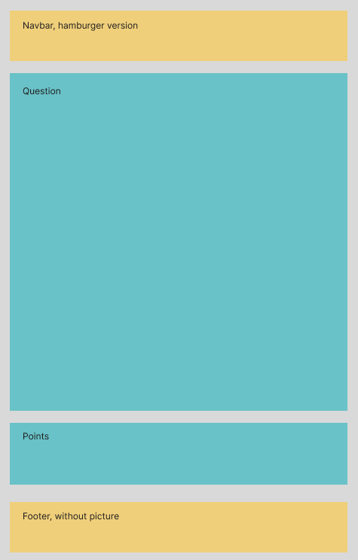Wireframe and colour scheme for Web-tekniikka -course Timo Hyttinen 13.12.2022

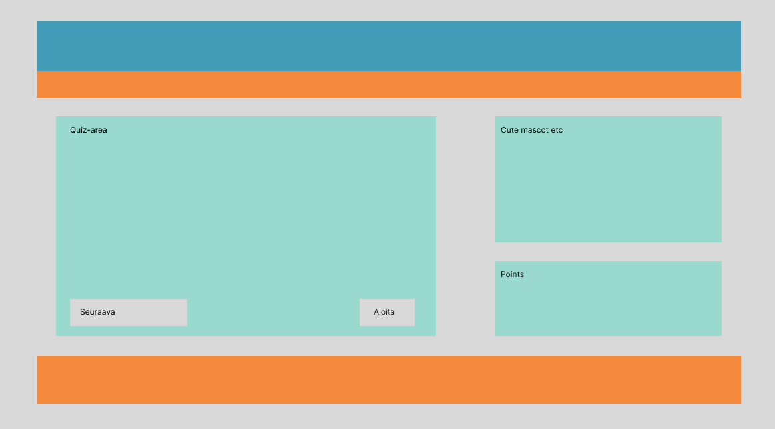Figure 1. Wireframe for mobile devices and smaller monitors

Figure 2. Wireframe for larger monitors

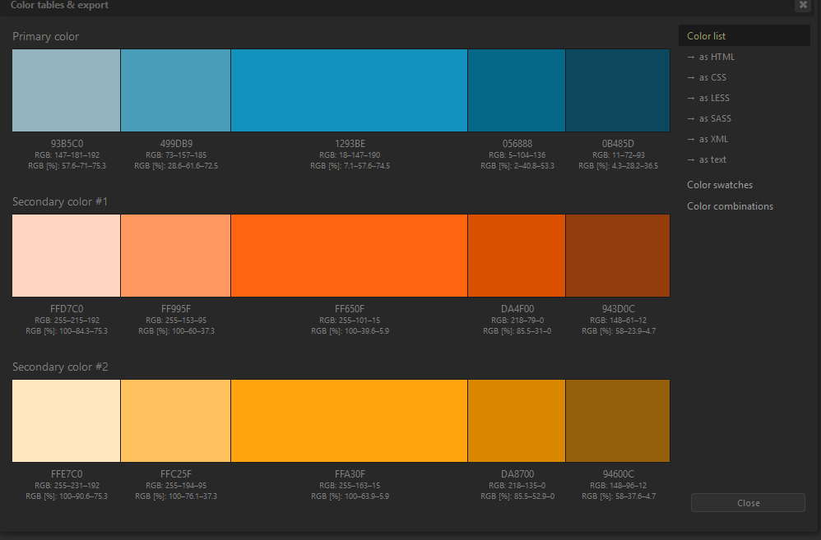Figure 3. Colour scheme for sites (used also in Web-projekti -course)